Issues Report — For MERN Team
Department 3 – HisabDo Website Enhancement | SQA Team
Website: hisabdo.app | Updated after Retest — Aug 24, 2026
This is an updated issues list following SQA's retest of MERN's first fix submission. Please review and address in priority order — ISS-10 should be fixed first as it is a critical, site-wide risk. Screenshot evidence is included below for the reported issues.

Issues to Fix / Clarify
ID | Area | Details | Priority | Status
ISS-10 | Critical Bug | Unresolved Git merge conflict markers (<<<<<<< HEAD / ======= / >>>>>>>) left in app/globals.css. This breaks the CSS file and must be fixed first, before anything else — please resolve the merge conflict properly and remove all conflict markers. | Critical | New
ISS-01 | Broken Link | GitHub link in founder profile still returns 404 (see evidence below). The href points to a repository URL that does not exist. Please verify and correct the actual GitHub URL (profile or repo, whichever is intended). | High | Still Open
ISS-05 | Responsiveness | Mobile spacing fix only works below 375px screen width (see evidence below). Most phones (390–430px) are not covered by the current media query — please widen the breakpoint (e.g. up to 480px) or use a flexible layout instead of a fixed breakpoint. | High | Partially Fixed
ISS-07/08/09 | Form Validation — Clarification Needed | SQA found that the Careers/Internship 'Apply Now' button links to an external Google Form, not a form in the website's own code (see evidence below — invalid data was accepted with no validation). Please confirm: is this intentional, or should this be replaced with an in-house form that MERN can validate? | High | Needs Clarification
ISS-02/03/04/06 | Performance | Image compression, layout shift (CLS), and unused JS/CSS fixes were claimed. SQA will re-run PageSpeed Insights once ISS-10 (CSS bug) is resolved, since the broken stylesheet may be affecting current measurements. | High | Pending Re-verification

Note
SQA will retest all items above once an updated build is submitted, and will also re-run PageSpeed Insights for performance-related items.

Evidence — Screenshots

ISS-01: GitHub Link Still Broken
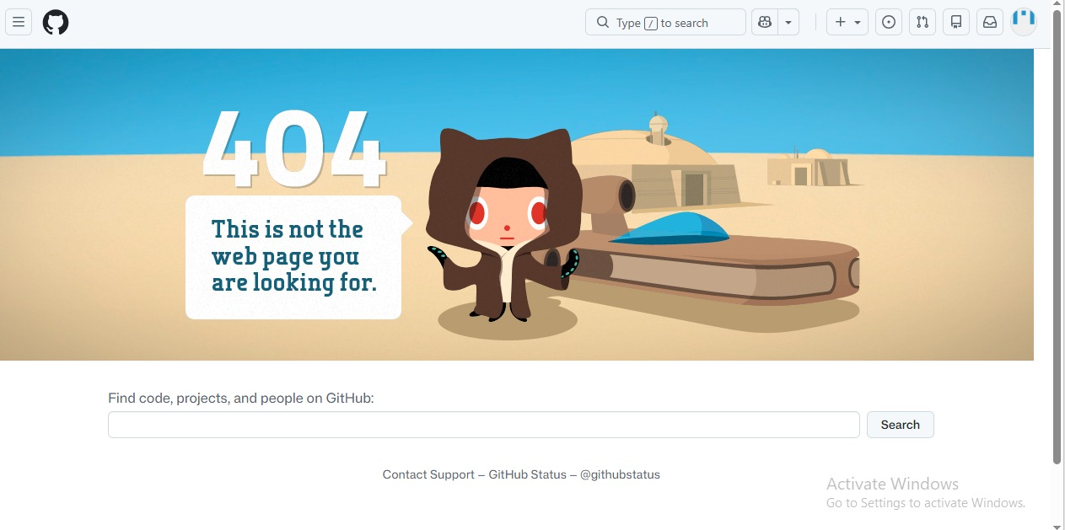
Clicking the GitHub link in the founder profile section leads to a GitHub 404 page.

ISS-07 / ISS-08 / ISS-09: Form Accepts Invalid Data
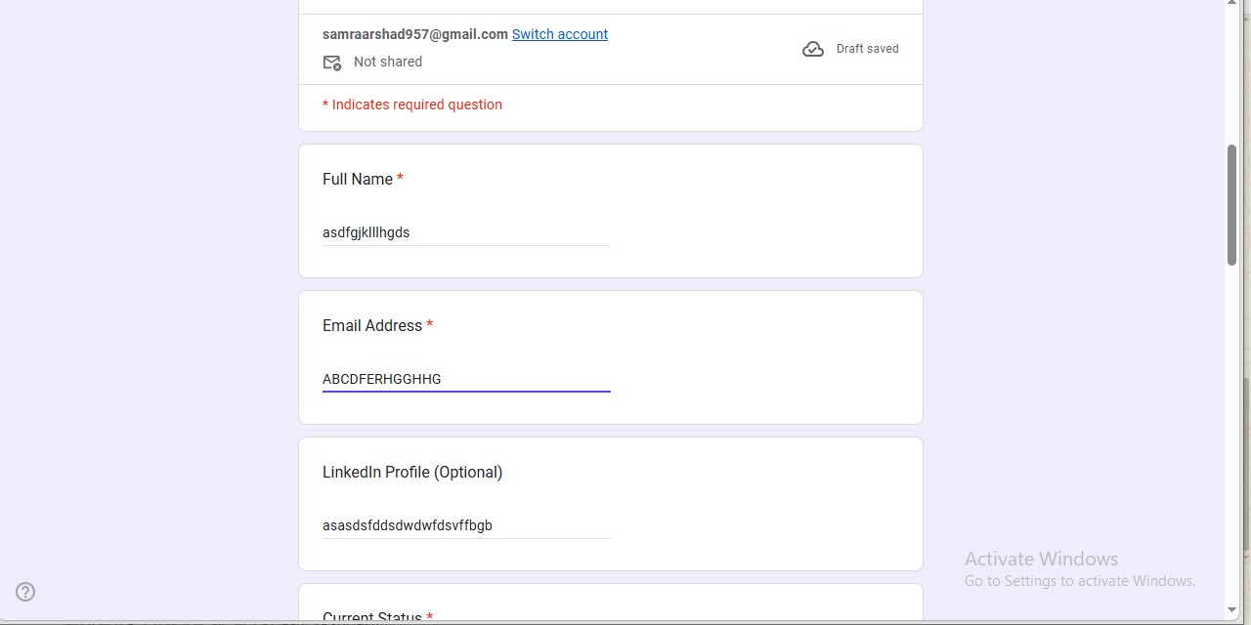
Random/invalid text entered in Full Name, Email Address, and LinkedIn Profile fields — no validation error shown.
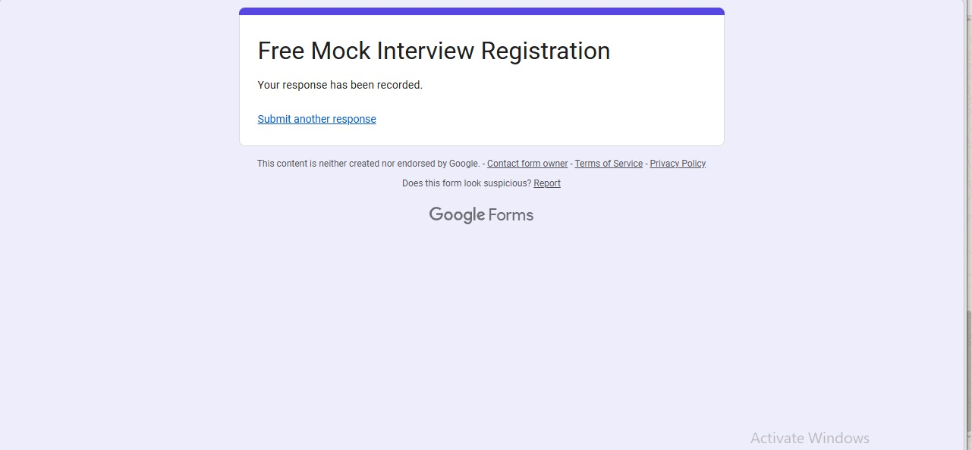
The form accepted the invalid data above and confirmed successful submission — proving no validation is in place.

ISS-05: Mobile Layout Overflow
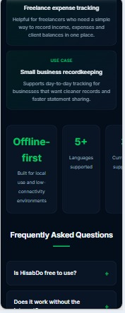
On mobile, the stat cards row overflows the screen width — the third card ('Currencies supported') is cut off and only partially visible.
Prepared by: Samra Arshad (SQA Team Lead)
Date: ______________________

